CHAPTER I. WHAT IS MACHINE LEARNING?

Machine learning is a rapidly growing field that has gained significant attention in recent years due to its wide range of applications and potential impact on society. It refers to the ability of machines to learn from experience and improve their performance without being explicitly programmed. The origin of machine learning can be traced back to the mid-20th century when researchers began developing algorithms and techniques to enable computers to learn and make decisions on their own.

One of the early pioneers of machine learning was Arthur Samuel, who in the early 1950s developed a program that could teach to play checkers. Samuel's approach involved creating a mechanism that allowed the program to update its decision-making process based on the outcomes of previous games. This idea of enabling machines to learn from data and improve their performance over time laid the foundation for modern machine learning algorithms. Another significant breakthrough in the field came in the 1980s with the development of neural networks. Neural networks are a class of algorithms that are inspired by the biological structure of the human brain. They consist of interconnected artificial neurons that can process and store information. By adjusting the strength of connections between neurons, neural networks can learn to recognize patterns and make predictions.

The availability of large datasets became a turning point for machine learning in the 1990s. These datasets provided researchers with the necessary information to train and validate their algorithms. Consequently, there was a significant increase in the development and application of machine learning techniques across various domains, including image and speech recognition, natural language processing, and predictive analytics. In recent years, advances in computational power, storage, and the availability of big data have fueled the exponential growth of machine learning. The field has experienced remarkable progress, such as the development of deep learning algorithms that can learn directly from raw data without feature engineering. Deep learning models, based on neural networks with multiple layers, have achieved groundbreaking results in various complex tasks, including image and speech recognition, autonomous driving, and natural language processing.

The widespread adoption of machine learning has been driven by the increased demand for intelligent systems that can analyze and make sense of large amounts of data. This has led to the emergence of applications such as recommendation systems, fraud detection, virtual assistants, and autonomous vehicles, among many others. Machine learning has also found applications in fields such as healthcare, finance, and manufacturing, where it has the potential to revolutionize processes and improve outcomes.

Machine learning has gained immense popularity and importance in recent years due to several reasons:

* Handling complex and large-scale data: With the explosion of data, traditional statistical models and manual data analysis approaches are often insufficient to extract meaningful insights. Machine learning algorithms can efficiently process and analyze large amounts of data to uncover patterns, trends, and relationships.
* Automation and efficiency: Machine learning can automate repetitive tasks and decision-making processes that were previously performed by humans. This improves efficiency and reduces the time and effort required to perform tasks such as data analysis, predictions, and pattern recognition.
* Adaptability and self-improvement: Machine learning algorithms are designed to continuously learn and improve from new data and experiences. As more data is fed into the system, the algorithms adapt, optimize, and enhance their performance, allowing them to provide more accurate and reliable predictions over time.
* Complex problem-solving: Machine learning algorithms excel at solving complex problems that may have multiple variables and dependencies. By leveraging advanced techniques like neural networks, deep learning, and reinforcement learning, machine learning can tackle challenges in various domains, such as speech recognition, image processing, natural language processing, recommendation systems, and autonomous vehicles.
* Personalization and recommendation: Machine learning enables personalized experiences and recommendations in various applications, such as online shopping, streaming services, news recommendations, and targeted marketing. By understanding user preferences and behavior patterns, machine learning algorithms can provide customized recommendations, leading to improved user engagement and satisfaction.
* Fraud detection and cybersecurity: Machine learning is instrumental in identifying and preventing fraudulent activities by analyzing large volumes of data and detecting patterns that indicate fraudulent behavior. It also helps in enhancing cybersecurity by identifying potential threats, analyzing system vulnerabilities, and devising proactive defense strategies.
* Healthcare advancements: Machine learning plays a crucial role in healthcare by analyzing patient data, medical records, and diagnostic images to aid in disease detection, treatment planning, drug discovery, and personalized medicine. Machine learning algorithms can assist in predicting patient outcomes, identifying high-risk individuals, and optimizing healthcare services.

CHAPTER II. GENERAL SEQUENCE OF WORK ON A MACHINE LEARNING TASK

The general sequence of work on a machine learning task typically involves the following steps:

* Problem Definition: Clearly define the problem you want to solve using machine learning techniques. This includes determining the task, defining the objectives, and understanding the data requirements.
* Data Collection: Gather relevant data for the problem at hand. This can involve acquiring data from various sources, such as databases, APIs, or web scraping. Ensure the quality and integrity of the data.
* Data Preprocessing: Clean and preprocess the collected data to make it suitable for analysis. This may involve handling missing values, dealing with outliers, normalizing, or scaling the data, and performing feature selection or feature engineering.
* Exploratory Data Analysis: Perform exploratory data analysis (EDA) to gain insights and understanding about the data. This can include visualizations, statistical summaries, correlation analysis, and identifying patterns or trends.
* Model Selection: Choose an appropriate machine learning algorithm that best suits your problem. Consider factors such as the type of problem (classification, regression, clustering), the nature of the data, performance requirements, interpretability, and scalability.
* Model Training: Split the preprocessed data into training and testing sets. Use the training set to train the machine learning model on the data. This involves learning the patterns and relationships in the data to make predictions or classifications.
* Model Evaluation: Evaluate the performance of the trained model using the testing data set. Use appropriate evaluation metrics based on the problem type (accuracy, precision, recall, F1 score, mean squared error, etc.). This helps measure the model's effectiveness and identify any shortcomings.
* Model Optimization: Fine-tune the model by adjusting parameters or trying different algorithms to improve its performance. This can involve techniques like cross-validation, hyperparameter tuning, or ensemble methods.
* Deployment: Once satisfied with the model's performance, deploy it in a real-world setting to make predictions or classifications on new, unseen data. This could involve integrating the model into an application, creating APIs, or embedding it in a production system.
* Monitoring and Maintenance: Continuously monitor the model's performance and make necessary updates or improvements as new data becomes available. Update the model periodically to ensure it stays accurate and relevant.

Figure 1 – Machine learning project workflow

Remember that the sequence and specific steps may vary depending on the nature of the problem, the available data, and the domain expertise. It is also an iterative process, and you might need to revisit different steps as you gain more insights or encounter challenges.

Data collection

Data collection refers to the process of gathering and measuring information on variables of interest, in order to answer research questions and evaluate outcomes. It involves systematically collecting and recording data, which can be structured (e.g., using standardized questionnaires) or unstructured (e.g., through observations or interviews).

There are various methods of data collection, including surveys, interviews, experiments, observations, and document analysis. Each method has its own strengths and limitations, and the choice of method depends on the research objectives, the nature of the data, and the available resources.

Data collection can be conducted using different tools and technologies, such as paper-based surveys, computer-assisted telephone interviews (CATI), web-based surveys, or mobile data collection apps. These tools allow for efficient data collection, storage, and analysis.

It is important to adhere to ethical principles and legal requirements when collecting data. Researchers must obtain informed consent from participants, maintain confidentiality and privacy, and ensure data security. Additionally, data collection procedures should be designed in a way that minimizes bias and ensures the validity and reliability of the collected data.

What is data?

Data refers to any collection of facts, figures, or information that can be processed, analyzed, and interpreted to derive insights, draw conclusions, and make decisions. Data can take many forms, including text, numbers, images, audio, and video. It can be generated by people, machines, or other sources, and it can be structured, semi-structured, or unstructured. In the context of computer science and information technology, data is often stored in databases, spreadsheets, or files, and it can be manipulated and analyzed using various tools and techniques, such as statistical analysis, machine learning, and data visualization.

Qualitative and quantitative data

In machine learning, both qualitative and quantitative data play important roles.

**Quantitative data** refers to numerical information that can be measured or counted, such as weights, lengths, or quantities. This type of data is often used for mathematical calculations, statistical analysis, and building models. Quantitative data is important in machine learning as it can be easily manipulated and processed by algorithms. It allows for precise measurements, comparisons, and mathematical operations, enabling the development of predictive models.

**Qualitative data**, on the other hand, refers to non-numerical information that describes qualities, attributes, or characteristics. This data is often obtained through observations, interviews, surveys, or other non-numeric methods. Qualitative data can include text, images, audio, or video. While qualitative data is less amenable to computation and mathematical analysis, it can provide valuable insights, context, and understanding that quantitative data alone may not capture.

In machine learning, qualitative data can be preprocessed and transformed into a format that algorithms can handle, such as feature extraction from images or sentiment analysis of text. Qualitative data can be used for training machine learning models alongside quantitative data, or it can be the primary focus in certain applications like natural language processing or image recognition. Combining qualitative and quantitative data can offer a more comprehensive view of the problem at hand and improve the performance and accuracy of machine learning models.

Cross-sectional data, time series, and panel data

Cross-sectional data, time series, and panel data are different types of data structures commonly encountered in machine learning.

1. Cross-sectional data: Cross-sectional data refers to observations collected at a specific point in time, typically from different individuals, entities, or units. Each observation represents a snapshot of the variables of interest at a given time. For example, if we collect data on the income, age, and education level of a group of individuals at a particular point in time, it would be considered cross-sectional data. In machine learning, cross-sectional data is often used to train models that predict outcomes for new, unseen individuals or entities.

2. Time series data: Time series data involves observations collected over multiple points in time, usually at regular intervals. This data is ordered chronologically, allowing for the study of trends, patterns, and forecasting future values. Time series analysis is used to model and predict future values based on past observations. Examples of time series data include stock prices, weather data, or population growth. Machine learning models can be trained on time series data to predict future values or detect anomalies.

3. Panel data: Panel data, also known as longitudinal or repeated measures data, combines cross-sectional and time series elements. It involves observations collected from multiple individuals, entities, or units over multiple time periods. Panel data can provide insights into both individual-level and time-related variations. For example, if we collect information on individuals' income, age, and education level over several years, it would be considered panel data. Machine learning techniques can be applied to panel data to model individual-level effects, time effects, and their interactions.

Different machine learning algorithms and techniques can be applied to analyze and make predictions based on each of these data structures. For example, regression models, decision trees, random forests, or recurrent neural networks are commonly used for analyzing time series data. Panel data can be handled using fixed effects models, random effects models, or hierarchical models. The choice of the appropriate machine learning approach depends on the specific research question, data characteristics, and desired outcomes.

**Data preprocessing**

Data preprocessing is an important step in machine learning that involves transforming raw data into a format that is suitable for analysis. It involves cleaning, transforming, and organizing the data to make it more manageable and accurate. The main goals of data preprocessing are to eliminate errors, handle missing values, reduce noise, and standardize the data.

Some common techniques used in data preprocessing include:

* Data cleaning: This involves handling missing values, duplicate data, and outliers. Missing values can be imputed using techniques like mean, median, or mode imputation. Duplicate data can be removed, and outliers can be treated by either removing them or transforming them to a more appropriate value.

***Handling missing values***

There are several ways to handle missing values in pandas:

* Identify missing values: Use the **isnull()** or **isna()** methods to identify missing values in a DataFrame or Series. These methods return a boolean mask where **True** values represent missing values.
* Drop missing values: Use the **dropna()** method to remove rows or columns with missing values. Specify the axis parameter to drop rows (axis=0) or columns (axis=1) containing missing values.
* Fill missing values with a specific value: Use the **fillna()** method to replace missing values with a specific value. You can provide a scalar value, a dictionary mapping column to values, or methods like 'ffill' or 'bfill' to propagate non-missing values forward or backward.
* Fill missing values with statistical measures: Use the **fillna()** method with statistical measures such as the mean, median, or mode to replace missing values with meaningful approximations. For example, df.fillna(df.mean()) will replace missing values with the mean of each column.
* Interpolate missing values: Use the **interpolate()** method to fill missing values with interpolated values based on the surrounding data.
* Ignore missing values for specific operations: Many pandas methods have optional parameters, like **skipna**, which allow you to ignore missing values when performing certain operations.
* Use masking to select non-missing values: Use the **notnull()** or **notna()** methods to create a boolean mask representing non-missing values, which can be used to select specific rows or columns.
* Use boolean indexing to filter missing values: Combine boolean masks generated by isnull() or isna() with boolean operators such as & (and) and | (or) to filter rows or columns based on the presence of missing values.

**Handling duplicates**

* Checking for duplicates: First, you need to determine if there are any duplicates in your DataFrame. You can use the **duplicated()** function, which returns a boolean Series indicating duplicate rows.

df.duplicated()

* Dropping duplicates: To remove duplicates from your DataFrame, you can use the **drop_duplicates()** function. By default, it keeps the first occurrence of each duplicated row and removes the rest.

df.drop_duplicates()

* Keeping specific duplicates: If you want to keep certain duplicates based on specific columns, you can use the **subset** parameter in drop_duplicates().

df.drop_duplicates(subset=['column1', 'column2'])

**Handling outliers**

* Identifying outliers: You can use statistical methods to identify outliers. For example, you can calculate the z-scores using the **zscore()** function from the scipy.stats module. Values with a z-score greater than a certain threshold (e.g., 3) are considered outliers.

from scipy.stats import zscore

z_scores = zscore(df['column'])

outliers = df[abs(z_scores) > 3]

* Percentile-based approach: You can also use quantiles to identify outliers. For example, values below the lower quartile (25th percentile) and above the upper quartile (75th percentile) can be considered outliers.

q1 = df['column'].quantile(0.25)

q3 = df['column'].quantile(0.75)

iqr = q3 - q1

outliers = df[(df['column'] < q1 - 1.5*iqr) | (df['column'] > q3 + 1.5*iqr)]

* Handling outliers: Once you have identified outliers, you can choose how to handle them. Common methods include replacing them with a specific value, removing them, or transforming them to a different value (e.g., capping at a certain threshold).

# Replacing outliers with a specific value

df.loc[outliers.index, 'column'] = specific_value

# Removing outliers

df = df.drop(outliers.index)

# Capping outliers at a threshold

df['column'] = np.where(df['column'] > threshold, threshold, df['column'])

* Data transformation: This involves transforming the data to make it suitable for analysis. Some common transformations include log transformation, square root transformation, and normalization. These transformations help in improving data distribution and reducing skewness.
* Encoding categorical variables: Categorical variables need to be converted into numerical values for machine learning algorithms to process them. This can be done using techniques like one-hot encoding or label encoding.
* Feature scaling: It is important to scale the features so that they fall within a similar range. Common scaling techniques include standardization (mean = 0, standard deviation = 1) and min-max scaling (values range between 0 and 1).
* Feature selection: This involves selecting the most relevant features for training the machine learning model. It helps in reducing dimensionality and improving model performance. Feature selection techniques include correlation analysis, forward selection, backward elimination, and lasso regression.
* Handling imbalanced data: When dealing with imbalanced datasets, where one class has significantly fewer samples than the other, techniques like oversampling, undersampling, or SMOTE (Synthetic Minority Over-sampling Technique) can be used to balance the data.

Oversampling and undersampling are techniques used in machine learning to address the issue of imbalanced datasets. In these techniques, we increase or decrease the number of instances of the minority or majority class to create a more balanced dataset.

To perform oversampling or undersampling using Pandas, you can follow these steps:

* Separate the minority and majority class examples in your dataset.
* Calculate the difference in count between the two classes.
* Based on whether you want to oversample or undersample, create an adjusted dataset by repeating or randomly removing instances from the minority or majority class.

Here's an example of oversampling using Pandas:

import pandas as pd

from sklearn.utils import resample

# Load the dataset

data = pd.read_csv('your_dataset.csv')

# Separate minority and majority classes

minority_class = data[data['target_variable'] == 'minority_class']

majority_class = data[data['target_variable'] == 'majority_class']

# Calculate the difference in count

minority_count = len(minority_class)

majority_count = len(majority_class)

count_diff = majority_count - minority_count

# Oversample the minority class by repeating instances

oversampled_minority = resample(minority_class, replace=True, n_samples=count_diff)

# Combine the oversampled minority class with the majority class

oversampled_data = pd.concat([majority_class, oversampled_minority])

# Now you have a balanced dataset

Similarly, you can perform undersampling by randomly removing instances from the majority class. Just replace the **count_diff** with **-count_diff** in the **resample()** function.

Remember to replace 'target_variable' with the actual column name used for identifying the classes in your dataset.

By performing these preprocessing steps, the data becomes more suitable for analysis, and it helps in improving the efficiency and accuracy of machine learning models.

**Exploratory data analysis (EDA)**

Exploratory Data Analysis (EDA) is an approach to analyzing and summarizing data in order to gain insights and understanding about its underlying patterns, structure, and relationships. It typically involves visualizing and summarizing the data using statistical and graphical techniques, such as histograms, scatter plots, and box plots, as well as computing summary statistics, such as mean, median, and standard deviation.

The purpose of EDA is to explore the data in a systematic way, in order to identify any patterns, trends, anomalies, or outliers that may be present, and to determine the appropriate methods for further analysis and modeling. EDA is often used as a preliminary step in data analysis, before more complex statistical or machine learning models are applied.

Some common techniques used in EDA include:

* Summarizing and visualizing the distribution of the data, such as through histograms or density plots.
* Examining the relationship between different variables, such as through scatter plots or correlation matrices.
* Identifying outliers or anomalies in the data, such as through box plots or scatter plots.
* Testing for statistical significance and exploring the impact of different assumptions and model specifications on the results.

Exploratory Data Analysis (EDA) can help identify trends in the data by examining the relationship between different variables and identifying patterns or changes in the data over time or across different groups. Some common techniques used in EDA to identify trends include:

* Line charts: Line charts can be used to plot the values of a variable over time or across different groups. By examining the overall trend in the data, analysts can identify patterns or changes over time, such as increasing or decreasing values.
* Scatter plots: Scatter plots can be used to examine the relationship between two variables. By plotting one variable on the x-axis and another variable on the y-axis, analysts can identify any patterns or relationships between the variables, such as a positive or negative correlation.
* Box plots: Box plots can be used to identify differences in the distribution of a variable across different groups. By comparing the median, quartiles, and outliers of the data for each group, analysts can identify any patterns or differences in the data.
* Heatmaps: Heatmaps can be used to visualize the relationship between two variables across different categories. By using color to represent the value of the variable, analysts can identify any patterns or trends in the data, such as higher values for certain categories.

EDA can help identify trends in the data by providing a visual and intuitive understanding of the relationship between different variables and the patterns or changes in the data over time or across different groups. This understanding can then be used to build predictive models or make informed decisions based on the data.

CHAPTER III. TYPES OF MACHINE LEARNING

There are three main types of machine learning: supervised learning, unsupervised learning, and reinforcement learning. Here is a brief overview of each type:

* Supervised Learning: Supervised learning involves training a machine learning model on labeled data, where each instance has a known target variable or output. The goal is to learn a mapping between the input features and the target variable, so that the model can make accurate predictions on new, unseen data. Supervised learning is commonly used for tasks such as classification, regression, and time series forecasting.
* Unsupervised Learning: Unsupervised learning involves training a machine learning model on unlabeled data, where there is no target variable or output to predict. The goal is to find patterns or structure in the data, such as clustering similar instances together or reducing the dimensionality of the data. Unsupervised learning is commonly used for tasks such as clustering, dimensionality reduction, and anomaly detection.
* Reinforcement Learning: Reinforcement learning involves training an agent to interact with an environment and learn to make decisions based on rewards and punishments. The goal is to learn a policy that maximizes a cumulative reward signal over time. Reinforcement learning is commonly used for tasks such as game playing, robotics, and optimization.

Machine learning is a rapidly evolving field, and there are many subfields and specialized techniques that fall under these three main types. For example, deep learning is a type of supervised learning that uses neural networks to model complex relationships between the input features and the target variable. Transfer learning is a type of unsupervised learning that involves reusing a pre-trained model on a new but related task. Overall, the choice of machine learning technique depends on the specific problem and the available data.

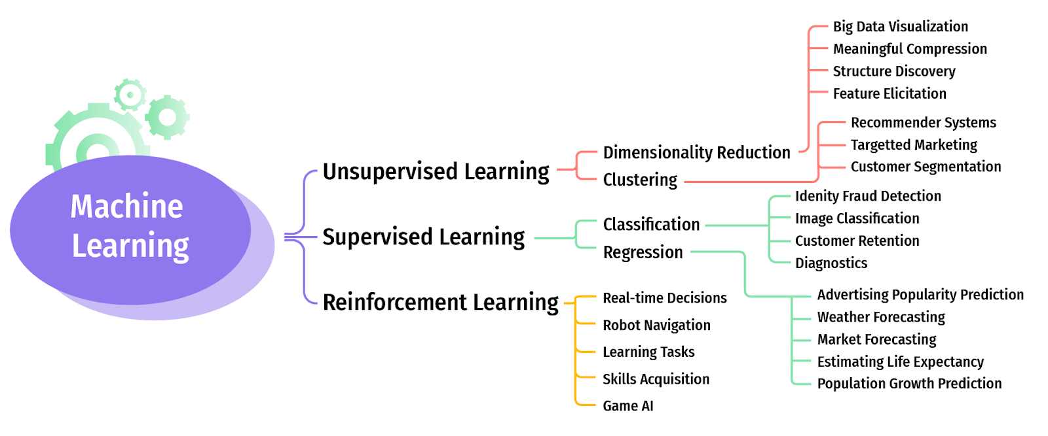

Figure 2 – Types of machine learning

**Supervised learning**

Supervised learning is a type of machine learning algorithm that involves training a model on a labeled dataset, where each data point is associated with a corresponding label or target variable. The goal of supervised learning is to learn a mapping between the input features and the output labels, so that the model can make accurate predictions on new, unseen data.

Supervised learning can be used for a variety of tasks, such as classification or regression. In classification, the goal is to predict a categorical label or class for each data point, while in regression, the goal is to predict a continuous value for each data point.

***Binary vs multiclass classification***

Binary classification and multiclass classification are two types of classification problems in machine learning. The main difference between the two is the number of possible output classes.

In binary classification, the output variable can take one of two possible values, typically represented as 0 and 1 or as "negative" and "positive". The goal of binary classification is to learn a model that can accurately predict the output value for new, unseen instances based on a set of input features. Examples of binary classification tasks include spam detection (where the output is either "spam" or "not spam") and fraud detection (where the output is either "fraudulent" or "non-fraudulent").

In multiclass classification, the output variable can take one of three or more possible values, each representing a distinct class or category. The goal of multiclass classification is to learn a model that can accurately predict the correct class label for new, unseen instances based on their input features. Examples of multiclass classification tasks include image classification (where the output is a label indicating the object or scene depicted in the image) and natural language processing (where the output is a label indicating the sentiment or topic of a sentence or document).

There are several algorithms and models that can be used for both binary and multiclass classification, such as logistic regression, decision trees, and neural networks. The main difference is that multiclass classification requires modifications to these algorithms to handle multiple output classes. For example, one approach is to use a one-vs-all (OVA) or one-vs-rest (OVR) strategy, where multiple binary classifiers are trained, each one distinguishing between one class and the rest of the classes.

Overall, the choice between binary and multiclass classification depends on the specific problem and the number of possible output classes. Binary classification is simpler and more straightforward, but it may not be sufficient for problems with more than two classes. Multiclass classification is more complex, but it can handle a wider range of problems with multiple output classes.

The process of supervised learning typically involves the following steps:

* Data preparation: The labeled dataset is divided into training and testing sets, and the input features are normalized or scaled as necessary.
* Model training: A machine learning algorithm is used to train the model on the labeled training data, by minimizing a loss function that measures the difference between the predicted outputs and the true outputs.
* Model evaluation: The trained model is evaluated on the testing data, by measuring its accuracy or performance using a suitable metric, such as precision, recall, or mean squared error.
* Model tuning: The model parameters and hyperparameters are adjusted as needed to improve its performance on the testing data.
* Model deployment: The final model is deployed to make predictions on new, unseen data.

Some common supervised learning algorithms include linear regression, logistic regression, decision trees, random forests, support vector machines (SVMs), and neural networks.

Supervised learning is a powerful and widely used technique in machine learning and data science, as it enables the development of accurate predictive models for a wide range of applications.

**Some common metrics used to evaluate supervised learning models**

There are several common metrics used to evaluate the performance of supervised learning models, depending on the task and the type of data. Here are some of the most commonly used metrics:

* Classification accuracy: This is the proportion of correctly classified instances over the total number of instances. It is a common metric for classification tasks, where the goal is to predict a categorical label. However, accuracy can be misleading when the classes are imbalanced or when the cost of misclassification is different for different classes.
* Precision and recall: These are metrics that are commonly used in binary classification tasks, where the goal is to predict a positive or negative outcome. Precision measures the proportion of true positive predictions over all positive predictions, while recall measures the proportion of true positive predictions over all actual positive instances. These metrics are useful when the cost of false positives and false negatives is different.
* F1-score: This is the harmonic mean of precision and recall, and it is commonly used as a single metric to evaluate binary classification models. It provides a balanced measure of both precision and recall, and it is useful when the classes are imbalanced.
* Mean squared error (MSE): This is a common metric for regression tasks, where the goal is to predict a continuous value. It measures the average squared difference between the predicted values and the true values.
* R-squared (R^2): This is another metric commonly used for regression tasks, which measures the proportion of variance in the target variable that is explained by the model. R^2 values range from 0 to 1, with higher values indicating a better fit.
* Receiver Operating Characteristic (ROC) curve and Area Under the Curve (AUC): These are commonly used to evaluate binary classification models. The ROC curve plots the true positive rate against the false positive rate at different classification thresholds, while the AUC measures the overall performance of the model.

**Applications of supervised learning**

Supervised learning has numerous applications in various fields, including:

* Image and speech recognition: Supervised learning models can be trained on labeled image and audio datasets to recognize and classify objects, faces, sounds, and speech.
* Natural language processing (NLP): Supervised learning models can be used to analyze and classify text data, such as sentiment analysis, language translation, and text summarization.
* Fraud detection: Supervised learning models can be trained to detect fraudulent transactions or activities in financial data, such as credit card transactions or insurance claims.
* Medical diagnosis: Supervised learning models can be trained on labeled medical data to diagnose diseases, predict patient outcomes, and identify potential risk factors.
* Customer churn prediction: Supervised learning models can be trained on customer data to predict which customers are likely to leave or churn, allowing businesses to take proactive measures to retain customers.
* Recommendation systems: Supervised learning models can be used to recommend products, movies, or other items to users based on their past behavior or preferences.
* Autonomous driving: Supervised learning models can be used to recognize and classify objects in real-time, allowing autonomous vehicles to make decisions based on their surroundings.

**Some challenges in supervised learning**

While supervised learning has many benefits and applications, there are also several challenges that can arise when working with this type of machine learning algorithm. Some of the most common challenges include:

* Data quality and quantity: Supervised learning models require labeled data to be effective, and the quality and quantity of the data can have a significant impact on the accuracy of the predictions. Poor quality data, such as data with missing values or incorrect labels, can lead to inaccurate or biased results.
* Overfitting and underfitting: Supervised learning models can suffer from overfitting, where the model is too complex and fits the training data too closely, or underfitting, where the model is too simple and fails to capture the underlying patterns in the data. Both of these issues can lead to poor performance on new, unseen data.
* Imbalanced classes: In classification tasks, the distribution of classes in the data can be imbalanced, with one class being much more prevalent than the others. This can lead to biased models that perform poorly on the minority class.
* Feature selection and engineering: Choosing the right set of features or variables to use in the model is critical to its performance. However, selecting the right features can be challenging, and may require domain expertise and experimentation.
* Scalability: Supervised learning models can become computationally expensive or infeasible to train on large datasets, especially when using complex models like neural networks.
* Interpretability: Some supervised learning models, such as neural networks, can be difficult to interpret and understand, making it challenging to identify the underlying factors that are driving the predictions.

**What are some ways to improve the interpretability of supervised learning models?**

Improving the interpretability of supervised learning models is an active area of research in machine learning, and there are several techniques and approaches that can be used to make the models more transparent and understandable. Here are some common methods:

* Feature importance: Some models, such as decision trees and random forests, provide a measure of feature importance, which can be used to identify the most important variables that are driving the predictions. This can help to identify the key factors that are influencing the model's output.
* Partial dependence plots: Partial dependence plots can be used to visualize the relationship between a feature and the predicted output, while holding all other features constant. This can help to identify the direction and strength of the relationship, and to determine whether the relationship is linear or nonlinear.
* Local interpretability: Techniques such as LIME (Local Interpretable Model-agnostic Explanations) and SHAP (Shapley Additive Explanations) can be used to provide local explanations of individual predictions, by identifying the features that are most important for a given prediction.
* Model simplification: Some models, such as linear regression, logistic regression, and decision trees, are inherently more interpretable than others, such as neural networks. In some cases, it may be possible to use a simpler model that is still effective, in order to improve interpretability.
* Ensembling: Ensemble methods, such as bagging and boosting, can be used to combine multiple models and improve their accuracy and stability. By using simpler models within the ensemble, it may be possible to improve interpretability without sacrificing too much performance.

**LIME and SHAP**

LIME (Local Interpretable Model-agnostic Explanations) is a method for explaining the predictions of any black-box model by approximating it with a simpler, interpretable model about the prediction. The basic idea behind LIME is to generate a set of perturbed instances around the instance of interest and fit a linear model on the perturbed instances to approximate the black-box model locally. The coefficients of the linear model are then used to explain the contribution of each feature to the prediction. LIME is model-agnostic, meaning that it can be applied to any black-box model, and it provides local explanations that can help to identify the key factors that are driving a particular prediction.

SHAP (Shapley Additive Explanations) is a method for explaining the predictions of any model by computing the contribution of each feature to the prediction using game theory. The basic idea behind SHAP is to compute the Shapley values, which are a way of assigning a fair share of the prediction to each feature based on its contribution to the prediction. The Shapley values are computed by considering all possible coalitions of features and their contributions to the prediction and averaging over all possible coalitions. SHAP is model-agnostic, meaning that it can be applied to any model, and it provides global explanations that can help to identify the key factors that are driving the predictions across the entire dataset.

Both LIME and SHAP are powerful tools for improving the interpretability of machine learning models, and they have been applied to a wide variety of applications, including image recognition, natural language processing, and healthcare. By providing explanations of the predictions, these methods can help to identify the key factors that are driving the model's output, and to build trust and understanding with end-users.

**Unsupervised learning**

Unsupervised learning is a type of machine learning where the goal is to find patterns or relationships in unlabeled data, without any specific target variable or output to predict. In unsupervised learning, the algorithm is not given any labeled examples to learn from, but rather must identify patterns or structure within the data on its own. Unsupervised learning can be used for exploratory data analysis, dimensionality reduction, clustering, anomaly detection, and other tasks.

There are several common types of unsupervised learning algorithms, including:

* Clustering: Clustering algorithms group similar instances together based on their similarity or distance. Examples of clustering algorithms include k-means, hierarchical clustering, and DBSCAN.
* Dimensionality reduction: Dimensionality reduction algorithms reduce the number of features or variables in the data while preserving the most important information. Examples of dimensionality reduction algorithms include principal component analysis (PCA) and t-SNE.
* Association rule mining: Association rule mining algorithms identify frequent itemsets or patterns in the data, such as which items are often purchased together in a supermarket. Examples of association rule mining algorithms include Apriori and FP-growth.
* Anomaly detection: Anomaly detection algorithms identify instances that are unusual or different from the majority of the data. Examples of anomaly detection algorithms include k-nearest neighbors and one-class SVM.

Unsupervised learning is a powerful tool for discovering patterns and relationships in large, complex datasets without the need for labeled examples. It is commonly used in applications such as customer segmentation, fraud detection, and recommendation systems.

**Some real-world applications of unsupervised learning**

Unsupervised learning has many real-world applications across various fields, including:

* Customer segmentation: Unsupervised learning algorithms can be used to group customers into segments based on their behavior, demographics, or other characteristics. This can help businesses to tailor their marketing strategies and improve customer engagement.
* Image and video analysis: Unsupervised learning algorithms can be used to analyze and classify images and videos based on their content, such as identifying objects, faces, or scenes.
* Anomaly detection: Unsupervised learning algorithms can be used to detect anomalies or outliers in large datasets, such as identifying fraudulent transactions or detecting unusual behavior in computer networks.
* Natural language processing (NLP): Unsupervised learning algorithms can be used to cluster similar documents or identify topics in large collections of text data, such as news articles or social media posts.
* Drug discovery: Unsupervised learning algorithms can be used to analyze molecular structures and identify potential drug candidates for further study.
* Recommendation systems: Unsupervised learning algorithms can be used to recommend products or services to users based on their past behavior or preferences, such as suggesting movies or music based on previous viewing or listening habits.
* Autonomous vehicles: Unsupervised learning algorithms can be used to analyze sensor data from autonomous vehicles to identify patterns and make decisions based on their surroundings.

Comparison between supervised and unsupervised learning

|  |  |
| --- | --- |
| Supervised learning | Unsupervised learning |
| * Requires labeled data, where each instance has a target variable or output to predict. * The goal is to learn a mapping between the input features and the target variable. * Can be used for classification, regression, and other tasks. * Performance can be evaluated using metrics such as accuracy, precision, recall, and F1-score. * Can be used for prediction, inference, and decision-making. * Requires less data to train compared to unsupervised learning. * Can be more interpretable and easier to understand than unsupervised learning. | * Does not require labeled data, and the goal is to find patterns or structure in the data. * Can be used for clustering, dimensionality reduction, anomaly detection, and other tasks. * Performance is evaluated using metrics such as silhouette score, clustering purity, and reconstruction error. * Can be used for exploratory data analysis and to gain insights into the data. * Requires more data to train compared to supervised learning. * Can be more difficult to interpret and understand than supervised learning. |

Reinforcement learning

Reinforcement learning is a type of machine learning that involves an agent interacting with an environment and learning to make decisions based on rewards and punishments. In reinforcement learning, the agent learns by trial-and-error, and the goal is to maximize a cumulative reward signal over time.

The basic components of a reinforcement learning system are:

* An agent: The decision-maker that interacts with the environment and learns from it.
* An environment: The external system that the agent interacts with and receives feedback from.
* Actions: The set of actions that the agent can take in the environment.
* State: The current state of the environment, which is observed by the agent.
* Rewards: The feedback signals that the agent receives from the environment after taking an action.
* Policy: The strategy or set of rules that the agent uses to select actions based on the observed state.

The goal of reinforcement learning is to learn a policy that maximizes a cumulative reward signal over time. The agent learns by trial-and-error, adjusting its policy based on the rewards and punishments received from the environment. The agent's goal is to learn a policy that maximizes the expected cumulative reward, which is often measured using a discount factor that gives more weight to immediate rewards.

Reinforcement learning has many real-world applications, such as:

* Game-playing: Reinforcement learning has been successfully applied to games such as chess, Go, and poker, where the agent learns to make decisions based on the current state of the game and the potential outcomes of different moves.
* Robotics: Reinforcement learning has been used to train robots to perform complex tasks, such as grasping objects, navigating environments, and interacting with humans.
* Finance: Reinforcement learning has been applied to financial trading, where the agent learns to make decisions based on market data and historical trends.
* Healthcare: Reinforcement learning has been used to optimize treatment plans for patients with chronic diseases, where the agent learns to make decisions based on patient data and clinical outcomes.

**Some challenges in reinforcement learning**

Reinforcement learning has many advantages and real-world applications, but there are also several challenges that must be addressed to ensure its effectiveness and practicality. Here are some common challenges in reinforcement learning:

* Exploration vs. exploitation: In reinforcement learning, the agent must balance the exploration of new actions and the exploitation of known actions to maximize the cumulative reward signal. Finding the optimal balance between exploration and exploitation can be challenging, especially in environments with high-dimensional state and action spaces.
* Credit assignment: In reinforcement learning, the agent receives feedback in the form of rewards, but it can be difficult to determine which actions or states contributed to the reward. This problem is known as credit assignment, and it can make it challenging to learn an effective policy.
* Generalization: Reinforcement learning algorithms must be able to generalize from the experience gained in one environment to new environments with similar but slightly different characteristics. This problem is known as transfer learning, and it can be challenging, especially when the new environments are significantly different from the training environment.
* Sparse rewards: In some environments, the reward signal is sparse, meaning that the agent only receives feedback after completing a long sequence of actions. Sparse rewards can make it difficult for the agent to learn an effective policy, as it may not receive feedback for a long time.
* Safety: In some real-world applications, such as robotics or healthcare, safety is a critical concern. Reinforcement learning algorithms must be designed to ensure safe and ethical behavior, and to avoid catastrophic failures.

Reinforcement learning is a powerful tool for decision-making in complex and dynamic environments, but it also poses several challenges that must be addressed to ensure its effectiveness and practicality. Ongoing research and development in reinforcement learning are focused on addressing these challenges and developing new algorithms and techniques to improve its performance and reliability.

CHAPTER IV. LINEAR REGRESSION: PRICE PREDICTION

Linear regression is a supervised learning technique used to model the relationship between a dependent variable (also known as the target variable) and one or more independent variables (also known as predictors or features). The goal of linear regression is to find the best linear relationship between the dependent variable and the independent variables, so that we can use this relationship to predict the value of the dependent variable for new, unseen data.

In linear regression, we assume that the relationship between the dependent variable and the independent variables is linear. The relationship is represented by a linear equation:

where:

y is the dependent variable

x1, x2, ..., xn are the independent variables

b0, b1, b2, ..., bn are the coefficients or weights of the model

The coefficients of the model are estimated using a training dataset, which consists of pairs of input and output values. The goal of linear regression is to find the values of the coefficients that minimize the difference between the predicted and actual values of the output variable. This difference is measured using a cost function, such as the mean squared error.

Once we have estimated the coefficients of the model, we can use it to make predictions on new, unseen data. Given the values of the independent variables for a new instance, we can use the linear equation to predict the value of the dependent variable.

Linear regression is a popular and widely used technique in machine learning, and it has many real-world applications, such as predicting stock prices, housing prices, and sales revenue. It is a simple but powerful technique that can be extended to more complex models, such as polynomial regression and multiple linear regression, which involve non-linear relationships and multiple independent variables.

**About House prediction Data set**

Problem Statement – A real estate agent wants help to predict the house price for regions in the USA. He gave you the dataset to work on and you decided to use the Linear Regression Model. Create a model that will help him to estimate what the house would sell for.

The dataset contains 7 columns and 5000 rows with CSV extension. The data contains the following columns:

* ‘Avg. Area Income’ – Avg. The income of the householder of the city house is located.
* ‘Avg. Area House Age’ – Avg. Age of Houses in the same city.
* ‘Avg. Area Number of Rooms’ – Avg. Number of Rooms for Houses in the same city.
* ‘Avg. Area Number of Bedrooms’ – Avg. Number of Bedrooms for Houses in the same city.
* ‘Area Population’ – Population of the city.
* ‘Price’ – Price that the house sold at.
* ‘Address’ – Address of the houses.

You can download the dataset from this [link](https://github.com/huzaifsayed/Linear-Regression-Model-for-House-Price-Prediction/blob/master/USA_Housing.csv)

Step 1. Open Google colab, create a new notebook, activate the environment

Step 2. Import libraries

Install the required libraries and setup the environment for the project. We will be importing SciKit-Learn, Pandas, Seaborn, Matplotlib and Numpy.

Scikit-learn is a popular open-source machine learning library for Python that provides a wide range of tools for supervised and unsupervised learning. It is built on top of NumPy, SciPy, and Matplotlib, and it provides a user-friendly interface for performing common machine learning tasks, such as classification, regression, clustering, and dimensionality reduction.

Scikit-learn provides a wide range of algorithms and models for different types of machine learning tasks. Some of the most used algorithms and models in scikit-learn are:

* Linear regression
* Logistic regression
* Support vector machines (SVMs)
* Decision trees and random forests
* K-nearest neighbors (KNN)
* Naive Bayes
* K-means clustering
* Principal component analysis (PCA)
* Gradient Boosting Machines (GBMs)

Scikit-learn also provides tools for data preprocessing, feature selection, and model evaluation, as well as utilities for handling common machine learning tasks, such as cross-validation and hyperparameter tuning.

One of the key strengths of scikit-learn is its ease of use and flexibility. It provides a consistent API across different algorithms and models, which makes it easy to switch between models and compare their performance. It also provides a wide range of configuration options and hyperparameters, which allows users to fine-tune their models for optimal performance.

Pandas is an open-source data analysis and manipulation library for the Python programming language. It provides a wide range of tools for working with structured data, such as numerical tables and time series data. Pandas is built on top of NumPy and provides an intuitive and powerful interface for data cleaning, transformation, and analysis.

Some of the key features of Pandas are:

* Data structures: Pandas provides two main data structures: Series (1-dimensional) and DataFrame (2-dimensional). These data structures are designed to handle both labeled and unlabeled data, and they provide a wide range of methods for working with data, such as filtering, grouping, and reshaping.
* Data cleaning and transformation: Pandas provides a wide range of tools for cleaning and transforming data, such as handling missing values, replacing values, and converting data types. It also provides methods for merging and joining data from different sources.
* Indexing and selection: Pandas provides powerful indexing and selection methods for accessing data in Series and DataFrame objects. These methods allow users to select data based on conditions, filter data based on specific criteria, and perform advanced operations such as pivoting and stacking.
* Time series analysis: Pandas provides specialized tools for working with time series data, such as resampling, shifting, and rolling window calculations. It also provides methods for handling time zones and working with date and time data.

import pandas as pd

import numpy as np

import seaborn as sns

import matplotlib.pyplot as plt

%matplotlib inline

The purpose of “%matplotlib inline” is to add plots to your Jupyter notebook.

Step 3. Loading the dataset and checking out

As data is in the CSV file, we will read the CSV using pandas read_csv function and check the first 5 rows of the data frame using head().

HouseDF = pd.read_csv('USA_Housing.csv')

HouseDF.head()

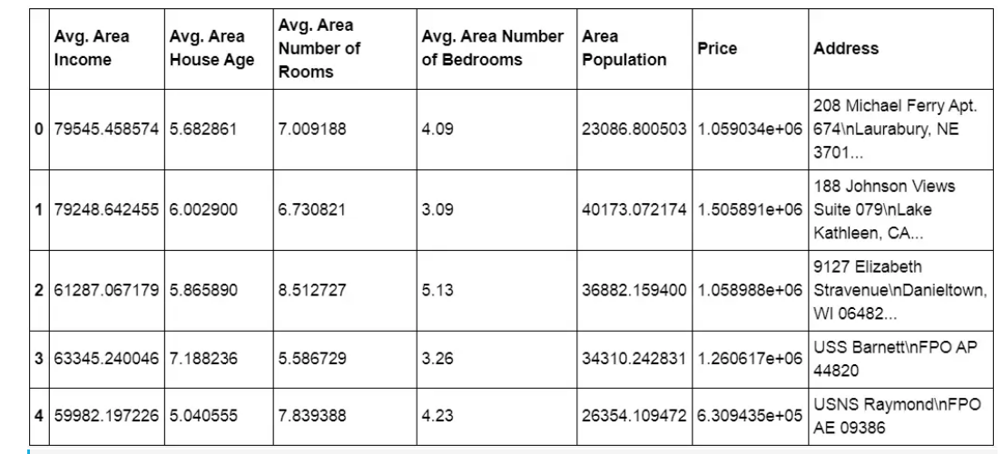

HouseDF.info()

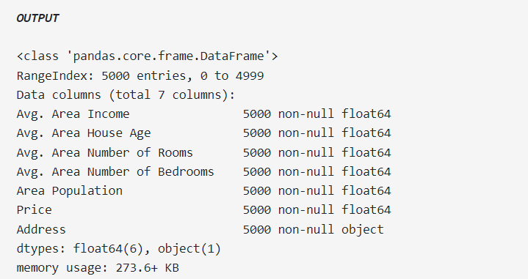

HouseDF.describe()

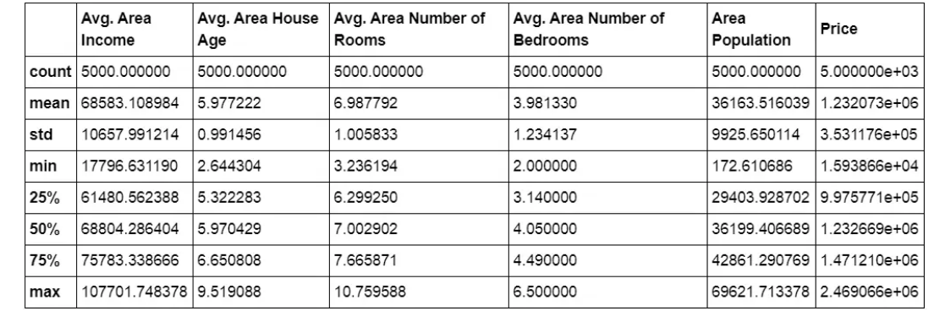

Step 4. Get Data Ready for Training a Linear Regression Model

Let’s now begin to train out the regression model. We will need to first split up our data into an X list that contains the features to train on, and a y list with the target variable, in this case, the Price column. We will ignore the Address column because it only has text which is not useful for linear regression modeling.

X = HouseDF[['Avg. Area Income', 'Avg. Area House Age', 'Avg. Area Number of Rooms',

'Avg. Area Number of Bedrooms', 'Area Population']]

y = HouseDF['Price']

Step 5. Split Data into Train, Test

Now we will split our dataset into a training set and testing set using sklearn train_test_split(). The training set will be used for training the model and testing set for testing the model. We are creating a split of 40% training data and 60% of the training set.

from sklearn.model_selection import train_test_split

X_train, X_test, y_train, y_test = train_test_split(X, y, test_size=0.4, random_state=101)

X_train and y_train contain data for the training model. X_test and y_test contain data for the testing model. X and y are features and target variable names.

Step 6. Creating and Training the LinearRegression Model

We will import and create sklearn linearmodel LinearRegression object and fit the training dataset in it.

from sklearn.linear_model import LinearRegression

lm = LinearRegression()

lm.fit(X_train,y_train)

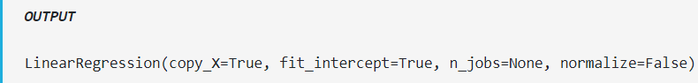

Step 7. LinearRegression Model Evaluation

Now let’s evaluate the model by checking out its coefficients and how we can interpret them.

print(lm.intercept_)

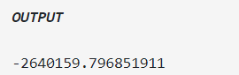

coeff_df = pd.DataFrame(lm.coef_,X.columns,columns=['Coefficient']) coeff_df

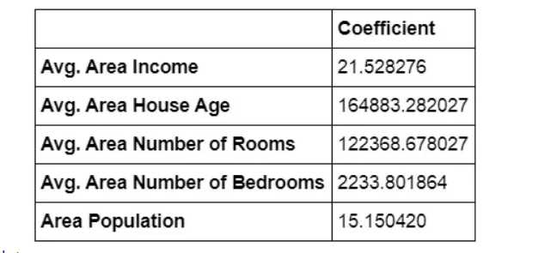

What does coefficient of data says:

* Holding all other features fixed, a 1 unit increase in Avg. Area Income is associated with an increase of $21.52 .
* Holding all other features fixed, a 1 unit increase in Avg. Area House Age is associated with an increase of $164883.28 .
* Holding all other features fixed, a 1 unit increase in Avg. Area Number of Rooms is associated with an increase of $122368.67 .
* Holding all other features fixed, a 1 unit increase in Avg. Area Number of Bedrooms is associated with an increase of $2233.80 .
* Holding all other features fixed, a 1 unit increase in Area Population is associated with an increase of $15.15 .

Step 8. Predictions from our Linear Regression Model

Let’s find out the predictions of our test set and see how well it performs.

predictions = lm.predict(X_test)

plt.scatter(y_test,predictions)

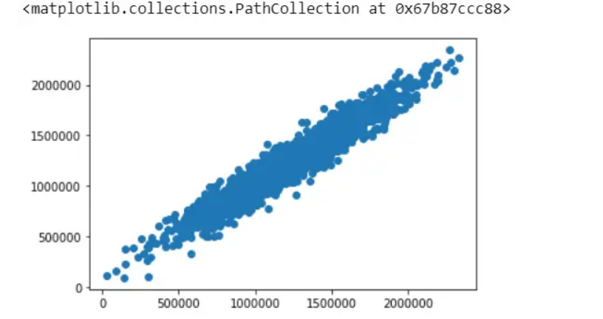

In the above scatter plot, we see data is in a line form, which means our model has done good predictions.

sns.distplot((y_test-predictions),bins=50);

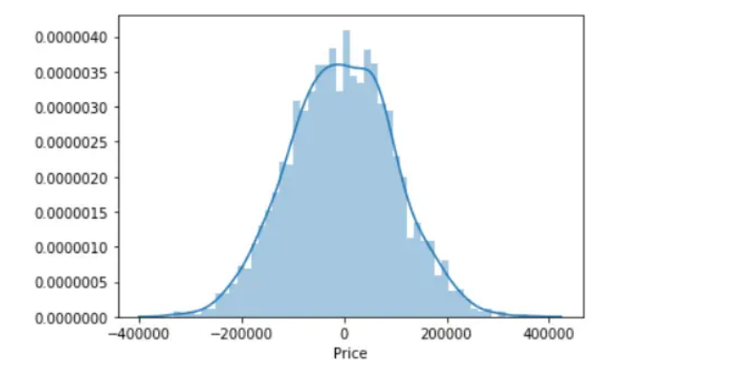

In the above histogram plot, we see data is in bell shape (Normally Distributed), which means our model has done good predictions.

**Regression Evaluation Metrics**

Here are three common evaluation metrics for regression problems:

Mean Absolute Error (MAE) is the mean of the absolute value of the errors:



Mean Squared Error (MSE) is the mean of the squared errors:



Root Mean Squared Error (RMSE) is the square root of the mean of the squared errors:



Comparing these metrics:

* MAE is the easiest to understand because it’s the average error.
* MSE is more popular than MAE because MSE “punishes” larger errors, which tends to be useful in the real world.
* RMSE is even more popular than MSE because RMSE is interpretable in the “y” units.

All of these are loss functions because we want to minimize them.

from sklearn import metrics

print('MAE:', metrics.mean_absolute_error(y_test, predictions)) print('MSE:', metrics.mean_squared_error(y_test, predictions)) print('RMSE:', np.sqrt(metrics.mean_squared_error(y_test, predictions)))

